Andrew Kozempel

Professor Avanzato

CMPSC 497

5 September 2023

**Homework 1A**

**Part 1: Data Analysis**

**Objective:** To analyze a list of voltages by calculating and displaying different statistical values and plots.

**MATLAB Script:**

| **%{ Andrew Kozempel CMPSC 497 Fall 2023 HW #1A Intro to MATLAB Statistics: Part 1 %}  % list of voltages voltages = [21.2, 19.5, 20.1, 18.3, 17.7, 15.0, 21.9, 24.7, 23.1, 20.2, 16.3, 22.8, 18.4, 23.5, 21.1];  % calculate min, max, average, SD, median, number of values above max minimum = min(voltages); maximum = max(voltages); average = mean(voltages); s_d = std(voltages); med = median(voltages); above_avg = find(voltages > average); length_above_avg = length(above_avg);   % print results fprintf('1. The minimum voltage is %.2f volts \n', minimum); fprintf('2. The maximum voltage is %.2f volts \n', maximum); fprintf('3. The average voltage is %.2f volts \n', average); fprintf('4. The standard deviation is %.2f volts \n', s_d); fprintf('6. The median voltage is %.2f volts \n', med); fprintf('7. The number of values above the average is %.2f volts \n', length_above_avg); fprintf('8. The values above the average: ') for i = 1:length_above_avg  fprintf('%.2f, ',voltages(above_avg(i))); end   % plot of raw data figure; plot(voltages, 'o-'); title('Voltage Measurements'); xlabel('Measurement'); ylabel('Voltage');  % histogram figure; histogram(voltages); title('Voltage Distribution'); xlabel('Voltage'); ylabel('Frequency');  fprintf('\n\n9. Plot open in new window'); fprintf('\n10. Histogram open in a new window');  % sorted data sorted = sort(voltages); fprintf('\n\n11. Sorted Data:\n');  for i = 1:length(sorted);  fprintf('%.2f \n', sorted(i)); end** |
| --- |

**Results:**

| >> HW_1A  1. The minimum voltage is 15.00 volts  2. The maximum voltage is 24.70 volts  3. The average voltage is 20.25 volts  4. The standard deviation is 2.76 volts  6. The median voltage is 20.20 volts  7. The number of values above the average is 7.00 volts  8. The values above the average: 21.20, 21.90, 24.70, 23.10, 22.80, 23.50, 21.10,  9. Plot open in new window  10. Histogram open in a new window  11. Sorted Data:  15.00  16.30  17.70  18.30  18.40  19.50  20.10  20.20  21.10  21.20  21.90  22.80  23.10  23.50  24.70 |
| --- |

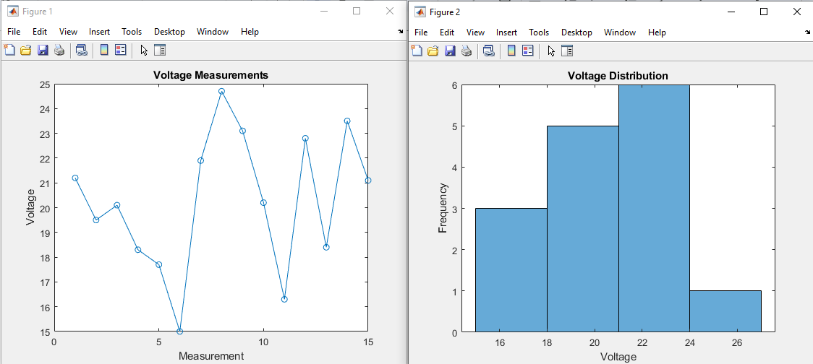

**Part 2A: Series Resistor Calculations**

**Objective:** To calculate the total resistance of resistors in series.

**MATLAB Script:**

| **%{ Andrew Kozempel CMPSC 497 Fall 2023 HW #1A Intro to MATLAB Statistics: Part 2 Series %}  % ask for input and initialize Rtotal num_res = input('Please enter the number of resistors: '); Rtotal = 0;  % ask for resistances for i = 1:num_res  fprintf('%d. ', i);  R = input('Please enter the resistance (ohms): ');  Rtotal = Rtotal + R; end  % print result fprintf('\nThe total resistance is %.2f ohms.\n', Rtotal);** |
| --- |

**Results:**

| **Test 1** | **Test 2** | **Test 3** |
| --- | --- | --- |
| >> series  Please enter the number of resistors: 5  1. Please enter the resistance (ohms): 4  2. Please enter the resistance (ohms): 9  3. Please enter the resistance (ohms): 7  4. Please enter the resistance (ohms): 6  5. Please enter the resistance (ohms): 8  The total resistance is 34.00 ohms. | >> series  Please enter the number of resistors: 6  1. Please enter the resistance (ohms): 12  2. Please enter the resistance (ohms): 45  3. Please enter the resistance (ohms): 7  4. Please enter the resistance (ohms): 64  5. Please enter the resistance (ohms): 4  6. Please enter the resistance (ohms): 58  The total resistance is 190.00 ohms. | >> series  Please enter the number of resistors: 4  1. Please enter the resistance (ohms): 45  2. Please enter the resistance (ohms): 8  3. Please enter the resistance (ohms): 14  4. Please enter the resistance (ohms): 46  The total resistance is 113.00 ohms. |

**Part 2B: Parallel Resistor Calculations**

**Objective:** To calculate the total resistance of resistors in parallel.

**MATLAB Script:**

| **%{ Andrew Kozempel CMPSC 497 Fall 2023 HW #1A Intro to MATLAB Statistics: Part 2 Parallel %}  % ask for input and initialize Rtotal num_res = input('Please enter the number of resistors: '); Rtotal = 0;  % ask for resistances for i = 1:num_res  fprintf('%d. ', i);  R = input('Please enter the resistance (ohms): ');  Rtotal = Rtotal + 1/R; end  % print result fprintf('\nThe total resistance is %.2f ohms.\n', 1/Rtotal);** |
| --- |

**Results:**

| **Test 1** | **Test 2** | **Test 3** |
| --- | --- | --- |
| >> parallel  Please enter the number of resistors: 5  1. Please enter the resistance (ohms): 4  2. Please enter the resistance (ohms): 9  3. Please enter the resistance (ohms): 7  4. Please enter the resistance (ohms): 6  5. Please enter the resistance (ohms): 8  The total resistance is 1.26 ohms. | >> parallel  Please enter the number of resistors: 6  1. Please enter the resistance (ohms): 12  2. Please enter the resistance (ohms): 45  3. Please enter the resistance (ohms): 7  4. Please enter the resistance (ohms): 64  5. Please enter the resistance (ohms): 4  6. Please enter the resistance (ohms): 58  The total resistance is 1.88 ohms. | >> parallel  Please enter the number of resistors: 4  1. Please enter the resistance (ohms): 45  2. Please enter the resistance (ohms): 8  3. Please enter the resistance (ohms): 14  4. Please enter the resistance (ohms): 46  The total resistance is 4.16 ohms. |

**Questions**

**1. What is MATLAB? (3 to 5 sentences)**

Matlab stands for ‘Matrix Laboratory’ and is developed by MathWorks. It is mainly used for data analysis and computation, along with visualization of that data. It is very useful for engineering fields, but is also used for other fields and professions, too. There are a lot of built in tools and functionalities that make it useful for a variety of different things.

**2. Is MATLAB compiled or interpreted? Explain.**

MATLAB is an interpreted language, meaning it is reading and executing line by line. However, it does seem like there is a way to compile MATLAB, if needed.

**3. Is MATLAB case sensitive? Give an example.**

Yes. Two variable names ‘x’ and ‘X’ will be viewed as two separate variables. This goes for files and functions, too.

**4. What are the advantages and disadvantages of using MATLAB instead of languages such as C++/C#/Java/Python?**

The main advantages of using MATLAB over other languages are that it is meant for numerical computation and it has an interactive workspace. This means that it makes it a better pick for certain needs regarding computation because of the tools and functionalities.

The main disadvantages are that it can be slower than some other languages and it is not free.

**5. Is MATLAB a “dynamically typed” language? Explain. Give one example.**

Yes, meaning you do not have to declare a variable’s data type and it will be determined during runtime. An example is ‘x = 5’ and x is determined to be an integer.

**6. Explain the colon “:” operator in MATLAB. Give an example.**

The colon operator is used to specify a range. It can be used for a few different cases. One would be to create a vector. An example is ‘x = 1:5’ creates a vector ‘[1,2,3,4,5]’. It can also be used to specify a range for a for loop.

**7. What is Simulink? (Research this on Mathworks website)**

Simulink is a graphical programing tool, also developed by MathWorks, used to model, simulate, and analyze various complex systems. It is an “add on” integrated with MATLAB to be a relatively smooth process. It uses a model based design for simulations, which is great for finding issues early. The interface is very user friendly because you can drag and drop blocks for the diagrams, which makes the process easier.